William Happer,
Professor of Physics, Emeritus, Princeton University

Richard Lindzen,
Professor of Earth, Atmospheric, and Planetary Sciences, Emeritus,
Massachusetts Institute of Technology

CO2 Coalition
Gregory Wrightstone, Executive Director
Non-profit 501(c)(3) educational foundation
Arlington, Virginia

SCIENCE DEMONSTRATES THE 4TH NATIONAL CLIMATE ASSESSMENT
IS MERELY GOVERNMENT OPINION, NOT SCIENCE, AND
OUR RECOMMENDATIONS FOR THE
USGCRP DECADAL STRATEGIC PLAN 2022–2031

July 22, 2022

Index

I. SUMMARY 2
II. EXPLAIN WHAT IS, AND IS NOT, SCIENCE: RELIABLE SCIENTIFIC THEORIES COME FROM VALIDATING THEORETICAL PREDICTIONS WITH OBSERVATIONS, NOT CONSENSUS, PEER REVIEW, GOVERNMENT OPINION OR MANIPULATED DATA 3
III. THE IPCC CMIP AND OTHER MODELS FAIL TO RELIABLY PREDICT TEMPERATURES, THUS MUST NOT BE USED AS SCIENCE IN ANY USGCRP STRATEGIC PLAN OR NCA 5
IV. THE IPCC IS GOVERNMENT CONTROLLED AND THUS ONLY ISSUES GOVERNMENT OPINIONS, WHICH MUST NOT BE USED AS SCIENCE IN ANY USCGCRP STRATEGIC PLAN OR NCA 7
V. THE 4th NATIONAL CLIMATE ASSESSMENT RELIES ON IPCC FINDINGS AND THUS IS MERELY GOVERNMENT OPINION AND NOT SCIENCE 10
VI. THERE WILL BE DISASTROUS CONSEQUENCES FOR THE POOR, PEOPLE WORLDWIDE, FUTURE GENERATIONS AND THE UNITED STATES BY REDUCING FOSSIL FUEL USE AND CO₂ EMISSIONS TO “NET ZERO” 10
A. CO₂ is Essential to Our Food, and Thus to Life on Earth. 10
B. Photosynthesis from Atmospheric CO₂ Sustains Most Live on Earth. 12
C. Greenhouse Gases Prevent Us from Freezing to Death 12
D. Enormous Social Benefits of Fossil Fuels 13
VII. CONCLUSION 14

SUMMARY

On May 26, 2022, the United States Global Change Research Program (“USGCRP”) explained it is developing a Decadal Strategic Plan 2022-31 and indicated they are focusing on three scientific areas:
- ideas on emerging, large-scale scientific questions related to global change and/or societal response, especially those where interagency collaboration will be critical;
- specific information on how science is or is not being used to inform societal response to global change, and why; and
- knowledge gaps and obstacles to implementing scientific tools or knowledge. 87 Fed. Reg. 32064-65.
Two of us (Happer & Lindzen) are career physicists who have specialized in radiation physics and dynamic heat transfer for decades. As a result, we think it is an important opportunity to do two things.
1st, explain why, with all due respect, science demonstrates that the 4th National Climate Assessment is merely government opinion, and therefore of no scientific value.
2nd, we have the following recommendations on the three scientific areas that the USGCRP are the is focusing on.
Explain What Is, and Is Not, Science. There is a breakthrough opportunity to inform the public and society on what is, and is not, science. Most people did not have the opportunity to specifically learn what is, and is not, science and scientific method.
Fortunately, the “key to science” and scientific method, in the words of Nobel Prize physicist Richard Feynman, is simple: does the theory work, does it accurately predict what is observed? If the theory doesn’t make accurate prediction of what is observed, the theory is rejected.
The public should not be confused by what does not determine reliable science:
consensus, peer review, government opinion, and manipulated data to make a theory work.
It would be a breakthrough public service if the Decadal Strategic Plan took major steps to inform the public on what is, and is not, science and that scientific method is simply testing a theory’s predictions with observations to see if it works.
Address the Many Ignored Large-Scale Scientific Questions. There are many large-scale scientific questions related to global change and major knowledge gaps and obstacles to implementing scientific knowledge that have been ignored and result from a confusion of what is, and is not, science.
- The International Panel on Climate Change (“IPCC”) and other models used to predict temperatures and scenarios fail the key test of science: they do not work with observations. They therefore must be rejected and not relied on as science in any USGCRP Strategic Plan or National Climate Assessment (“NCA”).
- The IPCC is government controlled. Therefore it only issues government opinions that have no scientific value. Therefore none of the IPCC findings can be used or relied on as science in any USGCRP Strategic Plan or NCA.
- With all due respect, the Fourth National Climate Assessment’s heavy reliance on IPCC findings means it provides merely government opinion and no reliable science.
- Contrary to scientific method, the enormous benefits of fossil fuels and CO2, and the disastrous consequences of reducing fossil fuels and CO2 to “net zero” are never considered. Scientifically any evidence contrary to any theory must be included and analyzed.
- Other important scientific questions and obstacles to implementing scientific knowledge are set forth in our (Professors Happer and Lindzen) comment on the proposed SEC disclosure rule, https://co2coalition.org/publications/16417/
- Robust additional evidence supporting these recommendations can be found in Gregory Wrightstone, Inconvenient Facts (2017) and the CO2 Coalition website, Home - CO2 Coalition
Details follow.

EXPLAIN WHAT IS, AND IS NOT, SCIENCE: RELIABLE SCIENTIFIC THEORIES COME FROM VALIDATING THEORETICAL PREDICTIONS WITH OBSERVATIONS, NOT CONSENSUS, PEER REVIEW, GOVERNMENT OPINION OR MANIPULATED DATA
Scientific knowledge is determined by scientific method. Prof. Richard Feynman, a Nobel Laureate in Physics, provided an incisive definition of scientific method:
“[W]e compare the result of [a theory’s] computation to nature, ... compare it directly with observations, to see if it works. If it disagrees with experiment, it is wrong. In that simple statement is the key to science.” The Character of Physical Law (1965), p. 150.
Agreement with observations is the measure of scientific truth. Scientific progress proceeds by the interplay of theory and observation. Theory explains observations and makes predictions of what will be observed in the future. Observations anchor understanding and weed out the theories that don’t work. This has been the scientific method for more than three hundred years.
Never, in our experience, has anything in science been beyond dispute. It is astounding that one of the most complex questions in physics (namely, the behavior of a multi-phase, radiatively active, turbulent fluid) should be labeled by the government — and funding agencies it controls — to be so settled that skeptics are silenced. That models supporting the climate-crisis narrative fail to describe observations confirms that the puzzle remains unsolved. Making this peculiar situation particularly dangerous are world leaders who have abandoned the science and intellectual rigor bequeathed to us by the Enlightenment and its forebears.
However, scientific knowledge is not determined by:
Consensus. What is correct in science is not determined by consensus. but by experiment and observations. Historically, scientific consensuses have often turned out to be wrong. The greatest scientists in history are great precisely because they broke with consensus. The frequent assertion that there is a consensus behind the idea that there is an impending disaster from climate change is not how the validity of science is determined to quote the profoundly true observation of Michael Crichton:
“If it’s consensus, it isn’t science. If it is science, it isn’t consensus.”
Government Opinion. Nobel physicist Richard Feynman put it clearly:
“No government has the right to decide on the truth of scientific principles.” The Meaning of It All (1998), p. 57.
The importance of the scientific principle that government does not determine science was chillingly underscored when Stalin made Trofim Lysenko the czar of Russian biology. False biology prevailed for 40 years in the Soviet Union because Lysenko gained dictatorial control, providing one of the most thoroughly documented and horrifying examples of the politicization of science. Lysenko was strongly supported by “scientists” who benefitted from his patronage. Millions died as a result. William Happer, Chapter 1 “Harmful Politicization of Science,” Michael Gough Ed., Politicizing Science (2003), pp. 29-35.
Peer Review. Peer review can be helpful in many areas of science, but it does not determine scientific validity. Agreement of theoretical predictions with observation or experiment, “the scientific method,” is the real touchstone of truth in science.
In our decades of personal experience in the field we have been dismayed that many distinguished scientific journals now have editorial boards that further the agenda of climate-change alarmism rather than objective science. Research papers with scientific findings contrary to the dogma of climate calamity are rejected by reviewers, many of whom fear that their research funding will be cut if any doubt is cast on the coming climate catastrophe. Journal editors have been fired for publishing papers that go against the party line of the climate-alarm establishment.
Alas, peer review of the climate literature is a joke. It is pal review, not peer review. The present situation violates the ancient principle “no man shall be a judge in his own cause.” Accordingly, all peer reviewed climate publications need to be viewed with skepticism. Some are right, but many have serious problems with confirmation bias.
Manipulated and Omitted Unfavorable Observations. Since theories are tested with observations, fabricating and omitting unfavorable facts to make a theory work is an egregious violation of scientific method.
Richard Feynman stated this fundamental principal of scientific method:
“If you’re doing an experiment, you should report everything that you think might make it invalid – not only what you think is right about it.… Details that could throw doubt on your interpretation must be given, if you know them.” 1974 Caltech commencement address, Surely You're Joking, Mr. Feynman! (1985), p. 311-12
U.S. Supreme Court on Science. The U.S. Supreme Court has adopted essentially the same view of science, starting in 1993 with its landmark Daubert decision:
“[I]n order to qualify as ‘scientific knowledge,’ an inference or assertion must be derived by the scientific method,” “any and all scientific testimony or evidence admitted [must be] ...reliable,” “tested,” and “supported by appropriate validation.” Daubert v. Merrell Pharmaceutical, Inc., 509 U.S. 579 (1993) (emphasis added).
Scientific evidence must be reliable, tested and validated -- or not be used.
As to peer review, the Supreme Court similarly explained that peer review can be helpful but "does not necessarily correlate with reliability" because "in some instances well-grounded but innovative theories will not have been published." Daubert, supra, p. 593.
Thus, there is a breakthrough opportunity to inform the public on what is, and is not, science, and that scientific knowledge is determined by scientific method, testing theory with observations, not by consensus, government opinion, peer review or manipulated data.
Further, these fundamental principles of science and scientific method are applied next.

III. THE IPCC CMIP AND OTHER MODELS FAIL TO RELIABLY PREDICT TEMPERATURES, THUS MUST NOT BE USED AS SCIENCE IN ANY USGCRP STRATEGIC PLAN OR NCA
The IPCC is the single most cited source of the theory that dangerous global warming is caused by human emissions of fossil fuels, CO₂ and other greenhouse gases. The IPPC is also, the dominant source of the models used in scenario predictions of dangerous climate warming.
However, the IPCC CMIP models (Coupled Model Intercomparison Project) do not reliably predict temperatures and therefore should be rejected under basic scientific method, demonstrated next.
CMIP5. John Christy, PhD, Professor of Atmospheric Science at the University of Alabama, applied the scientific method to CMIP5 102 predictions of temperatures 1979-2016 by models from 32 institutions.
He explained he used “the traditional scientific method in which a claim (hypothesis) is made and is tested against independent information to see if the claim can be sustained,” and produced the following chart:
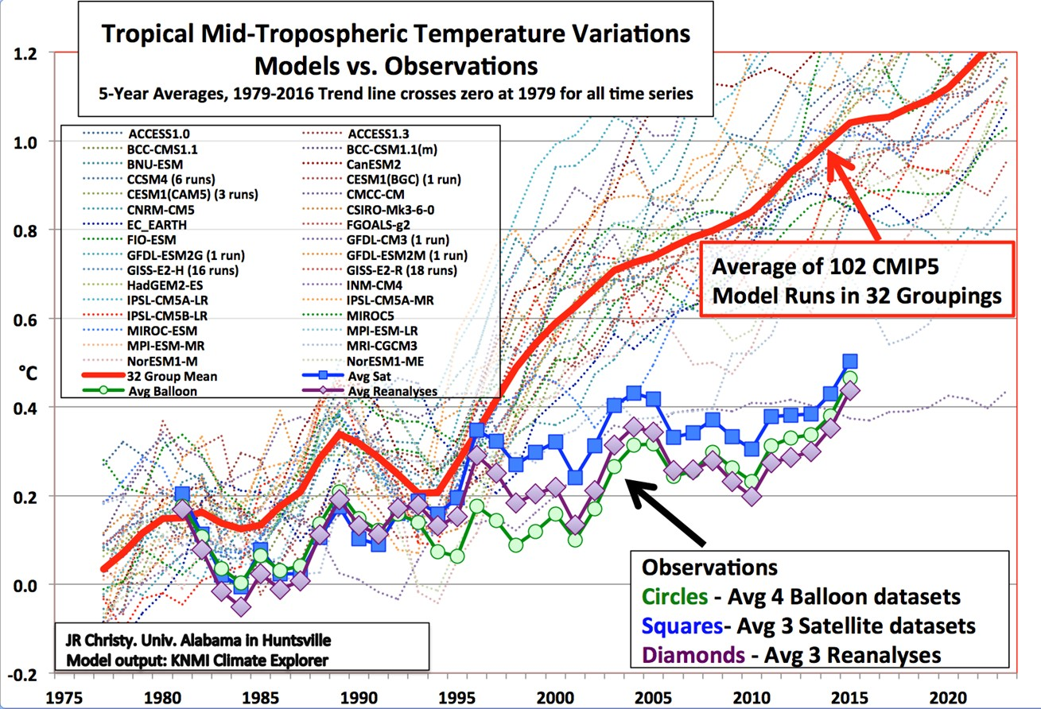
At the bottom, the blue, purple and green lines show the actual reality temperature observations against which the models’ predictions were tested.
The dotted lines are 102 temperature “simulations” (predictions) made by the models from 32 institutions for the period 1979-2016.
The red line is the consensus of the models, their average.
The graph clearly shows 101 of the 102 predictions by the models (dotted lines) and their consensus average (red line) fail miserably to predict reality. Focusing on the consensus red line, he concluded:
“When the ‘scientific method’ is applied to the output from climate models of the IPCC AR5, specifically the bulk atmospheric temperature trends since 1979 (a key variable with a strong and obvious theoretical response to increasing GHGs in this period), I demonstrate that the consensus of the models [red line] fails the test to match the real-world observations by a significant margin. As such, the average of the models is considered to be untruthful in representing the recent decades of climate variation and change, and thus would be inappropriate for use in predicting future changes in the climate or related policy decisions.” Id., p. 13 (emphasis added).
Thus, the models that produced the 101 predictions fail the Feynman test under scientific method. They do not “work,” and therefore have no scientific value and should be rejected.
CMIP6. Steven Koonin, Phd., a Cal-Tech physicist, professor at New York

University and author of Unsettled (2021), concluded:
“One stunning problem is that … the later generation of [CMIP] models are actually more uncertain than the earlier one[s].”
“The CMIP6 models that inform the IPCC’s upcoming AR6 [Climate Change reports] don’t perform any better than those of CMIP5.” Id. pp. 87, 90 (emphasis added).
He elaborated CMIP6’s failure using the scientific method in detail:
- “An analysis of 267 simulations run by 29 different CMIP6 models created by 19 modeling groups around the world shows that they do a very poor job [1] describing warming since 1950 and … [2] underestimate the rate of warming in the early twentieth century.” Id. p. 90 (emphasis added).
- “Comparisons among the [29] models [show] … model results differed dramatically both from each other and from observations ... [and] disagree wildly with each other.” Id. p. 90 (emphasis added).
- “One particularly jarring failure is that the simulated global average surface temperature … varies among models … three times greater than the observed value of the twentieth century warming they’re purporting to describe and explain.” Id. p. 87 (emphasis added).
- As to the early twentieth century warming when CO₂ levels only increased from 300 to 310 ppm, “strong warming [was] observed from 1910 to 1940. On average, the models give a warming rate over that period of about half what was actually observed. That the models can’t reproduce the past is the big red flag -- it erodes confidence in their projections of future climate.” Id. pp. 88, 95 (emphasis added).
Thus the CMIP6 model also fails the fundamental test under scientific method: they do not work and thus also have no scientific value and should be rejected.
Other Models. Prof. Koonin’s book devoted an entire chapter to “Many Muddled Models,” not just the CMIP models.
He asked, “how good are our climate models? And how much confidence should we have in what they say about future climates?” He concluded all the models are “demonstrably unfit for the purpose,” elaborating:
“The uncertainties in modeling of both climate change and the consequences of future greenhouse gas emissions make it impossible today to provide reliable, quantitative statements about relative risks and consequences and benefits of rising greenhouse gases to the Earth system as a whole, let alone to specific regions of the planet.” Unsettled, pp. 24, 96.
In conclusion, the IPCC CMIP models that are widely used, and are the basis for the IPCC climate risk assessments and scenarios that are central to the press predictions of catastrophic global warming caused by fossil fuels and increased CO2 fail the fundamental test of scientific method. They do not work. Contrary to common reporting, they provide no reliable scientific evidence there is any climate-related risk caused by fossil fuels and CO_{2.} Thus they must not be relied on as science in any USGCRP Strategic Plan or NCA.

IV. THE IPCC IS GOVERNMENT CONTROLLED AND THUS ONLY ISSUES GOVERNMENT OPINIONS, WHICH MUST NOT BE USED AS SCIENCE IN ANY USCGCRP STRATEGIC PLAN OR NCA
Unknown to most, two IPCC rules require that IPCC governments control what it reports as “scientific” findings on CO2, fossil fuels and manmade global warming, not scientists. IPCC governments meet behind closed doors and control what is published in its Summaries for Policymakers (“SPMs”), which controls what is published in full reports. The picture below tells all.

IPCC Summary for Policymakers writing meeting
This not how scientific knowledge is determined. In science, as the Lysenko experience chillingly underscores, and as Richard Feynman emphasized:
“No government has the right to decide on the truth of scientific principles.”
The two IPCC rules are:
IPCC SPM Rule No.1: All Summaries for Policymakers (SPMs) Are Approved Line by Line by Member Governments
“IPCC Fact Sheet: How does the IPCC approve reports? ‘Approval’ is the process used for IPCC Summaries for Policymakers (SPMs). Approval signifies that the material has been subject to detailed, line-by-line discussion, leading to agreement among the participating IPCC member countries, in consultation with the scientists responsible for drafting the report.”
Since governments control the SPMs, the SPMs are merely government opinions. Therefore, they have no value as reliable scientific evidence.
What about the thousands of pages in the IPCC reports? A second IPCC rule requires that everything in an IPCC published report must be consistent with what the governments agree

to in the SPMs about CO₂ and fossil fuels. Any drafts the independent scientists write are rewritten as necessary to be consistent with the SPM.
IPCC Reports Rule No. 2: Government SPMs Override Any Inconsistent Conclusions Scientists Write for IPCC Reports
IPCC Fact Sheet: “’Acceptance’ is the process used for the full underlying report in a Working Group Assessment Report or a Special Report after its SPM has been approved.... Changes ...are limited to those necessary to ensure consistency with the Summary for Policymakers.” IPCC Fact Sheet, supra. (Emphasis added).
IPCC governments’ control of full reports using Rule No. 2 is poignantly demonstrated by the IPCC’s rewrite of the scientific conclusions reached by independent scientists in their draft of Chapter 8 of the IPCC report Climate Change 1995, The Science of Climate Change (“1995 Science Report”). The draft by the independent scientists concluded:
“No study to date has positively attributed all or part (of the climate warming observed) to (manmade) causes.”
"None of the studies cited above has shown clear evidence that we can attribute the observed [climate] changes to the specific cause of increases in greenhouse gases." Frederick Seitz, “A Major Deception on Climate Warming,” Wall Street Journal (June 12, 1996).
However, the government written SPM proclaimed the exact opposite as to human influences:
“The balance of evidence suggests a discernible human influence on global climate.” 1995 Science Report SPM, p. 4.
What happened to the independent scientists’ draft? IPCC Rule No. 2 was applied, and their draft was rewritten to be consistent with the SPM in numerous ways:
- Their draft language was deleted.
- the SPM’s opposite language was inserted in the published version of Chapter 8 in the 1995 Science Report, on page 439: “The body of statistical evidence in chapter 8 ... now points towards a discernible human influence on global climate.”
- The IPCC also changed “more than 15 sections in Chapter 8 of the report ... after the scientists charged with examining this question had accepted the supposedly final text.” Seitz, supra.
As to the full IPCC reports, hundreds of world-class scientists draft some very good science. What to do? Use a presumption that anything in IPCC reports should be presumed to be government opinion with no value as reliable scientific evidence, unless independently verified by scientific method.
Stop for a moment. Just imagine what would have happened if the IPCC accurately reported the science. The scientists concluded there was no science that attributed all or most of the climate warming observed to manmade causes.
There would be no Massachusetts v. EPA, Green New Deal,” Net Zero” regulation, efforts to eliminate fossil fuels, huge subsidies of renewable energy and electric cars. For whatever reason, the IPCC as a government-controlled organization did not and has never followed the science if the science contradicts the theory of catastrophic global warming caused by fossil fuels and other human emissions.
In conclusion, none of the IPCC SPMs, models, scenarios and other findings asserting that dangerous climate warming is caused by human CO₂ and GHG emissions and fossil fuels are reliable scientific evidence, they are merely the opinions of IPCC governments.
Thus the IPCC SPMs, models, scenarios and other findings provide no reliable scientific evidence there is any climate related risk caused by fossil fuels and increased CO₂. Thus they must not be relied on as science in any USGCRP Strategic Plan or NCA.

V. THE 4th NATIONAL CLIMATE ASSESSMENT RELIES ON IPCC FINDINGS AND THUS IS MERELY GOVERNMENT OPINION AND NOT SCIENCE
The USGCRP Fourth National Climate Assessment, Vol. I Climate Science Special Report (2017) ("NCA4 Science") relies on IPCC models and opinions that are government controlled “science.”
The “USGCRP Web site states that: ‘When governments accept the IPCC reports and approve their Summary for Policymakers, they acknowledge the legitimacy of their scientific content.’”
However, legitimacy of scientific content is not determined by government, Richard Feynman emphasized, as noted: “No government has the right to decide on the truth of scientific principles.” Legitimacy of scientific content is determined by scientific method.
Unfortunately, the NCA4 Science report chose to rely on IPCC government controlled “scientific” findings over 240 times, contaminating its science with IPCC government controlled dictated opinions.
Thus, with all due respect, the NCA4 Science report is merely a government opinion, and provides no reliable scientific evidence there is any climate related risk caused by fossil fuels and CO2.

VI. THERE WILL BE DISASTROUS CONSEQUENCES FOR THE POOR, PEOPLE WORLDWIDE, FUTURE GENERATIONS AND THE UNITED STATES BY REDUCING FOSSIL FUEL USE AND CO₂ EMISSIONS TO “NET ZERO”
There is overwhelming scientific evidence that fossil fuels and CO₂ provide enormous social benefits or low-income people, people worldwide, future generations and United States. True science also demonstrates that reducing fossil fuel use and CO₂ emissions to “net zero” will not benefit the climate but will be disastrous for the economy of the United States and the world.
Lower income people will be particularly hard hit, especially in less developed countries.

A. CO₂ is Essential to Our Food, and Thus to Life on Earth.
Contrary to what is usually reported, CO₂, fossil fuels and greenhouse gases threaten life on the planet, they in fact are essential to life on Earth. Without them, there would be no human or other life on earth.
We owe our existence to green plants that, through photosynthesis, convert CO₂ and water, H₂O, to carbohydrates with the aid of sunlight, and release oxygen. Land plants get the carbon they need from the CO₂ in the air. Other essential nutrients — water, nitrogen, phosphorus, potassium, etc. — come from the soil. Just as plants grow better in fertilized, well-watered soils, they grow better in air with several times higher CO₂ concentrations than present values. As far as green plants are concerned, CO₂ is part of their daily bread—like water, sunlight, nitrogen, phosphorus, potassium and other essential elements.
Without CO₂, there would be no photosynthesis, no food and no human or other life.
What happens with a doubling of CO₂? Many experiments and studies confirm that when CO₂ is doubled, agricultural yields are increased significantly, especially in arid regions where more CO₂ increases the resistance of plants to droughts. Greenhouse operators routinely pay to double or triple the concentrations of CO₂ over their plants. The improved yield and quality of fruits and flowers more than pay for the cost of more CO₂, with only small and beneficial warming.
A dramatic example of the response of green plants to increases of atmospheric CO₂ is shown below: Dr. Sherwood Idso grew Eldarica (Afghan) pine trees with increasing amounts of CO₂ in experiments about 10 years ago, starting with an ambient concentration of CO₂ of 385 ppm. He showed what happens over the 10 years when CO₂ is increased by 150, 300 and 450 ppm, for total CO₂ concentrations of 385, 535, 685 and 835 ppm:

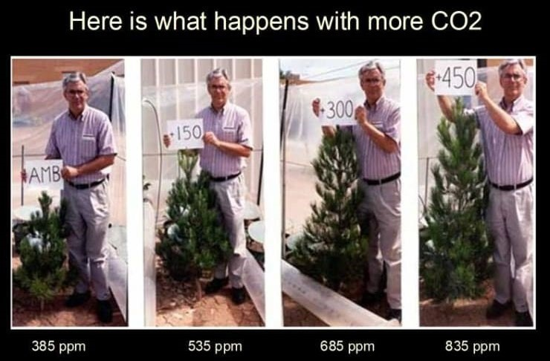

More CO₂ has made a significant contribution to the increased crop yields of the past 50 years, as well. The benefits to plants of more CO₂ are documented in hundreds of scientific studies.

B. Photosynthesis from Atmospheric CO₂ Sustains Most Live on Earth.
Nearly all of the food we eat comes ultimately from photosynthesis on the land or in the oceans. The oxygen we breathe was produced by photosynthesis over the geological history of the Earth. In the process of photosynthesis, energy from sunlight forces molecules of water, H₂O, and molecules of carbon dioxide and CO₂ to combine to make sugars and other organic molecules. A molecule of oxygen, O₂, is released to the atmosphere for every molecule of CO₂ converted to sugar. An interesting scientific aside is that the O₂ comes from the water molecules, H₂O, used in photosynthesis, not from CO₂.
Without CO₂, there would be no photosynthesis, plants would die and the animals that eat them would starve to death, and most higher life forms would become extinct. The peculiar biological communities at deep sea vents and various chemotropic bacteria in sediments below Earth’s surface would be all that remains of the once flourishing web of life that was sustained by atmospheric CO_{2,} water and sunlight.
Most green plants evolved at CO₂ levels of several thousand parts per million (ppm), many times higher than now. Plants grow better and produce better flowers and fruit at higher levels. Commercial greenhouse operators recognize this when they artificially increase CO₂ concentrations inside their greenhouses to over 1,000 ppm.
All green plants grow faster with more atmospheric CO₂, including the CO₂ released by the combustion of fossil fuels, which is almost identical to the CO₂ respired by human beings and other living creatures.

C. Greenhouse Gases Prevent Us from Freezing to Death
Greenhouse gases hinder the escape of thermal radiation to space. We should be grateful for them. Greenhouse gases keep the Earth’s surface temperature warm enough and moderate enough to sustain life on our verdant planet. Without them, we’d freeze to death.
To quote John Tyndall, the Anglo-Irish physicist who discovered greenhouse gases in the 1850’s:
“Aqueous vapor is a blanket, more necessary to the vegetable life of England than clothing is to man. Remove for a single summer-night the aqueous vapor from the air which overspreads this country, and you would assuredly destroy every plant capable of being destroyed by a freezing temperature. The warmth of our fields and gardens would pour itself unrequited into space, and the sun would rise upon an island held fast in the iron grip of frost." John Tyndall, Heat, a Mode of Motion (5th Ed. 1875).
Tyndall identified “aqueous vapor” (water vapor) as the most important greenhouse gas. Water vapor, and clouds which condense from it, are the dominant greenhouse agents of Earth’s atmosphere.
Carbon dioxide, CO₂, is also a greenhouse gas, and does cause a small amount of warming of our planet. But it is far less effective than water vapor and clouds.
Without the greenhouse warming of CO₂ and its more potent partners, water vapor and clouds, the earth would be too cold to sustain its current abundance of life. We would freeze.

D. Enormous Social Benefits of Fossil Fuels
Contrary to the incessant attack on fossil fuels, affordable, abundant fossil fuels have given ordinary people the sort of freedom, prosperity and health that were reserved for kings in ages past.
The following chart of the GDP per person for the last 2,000 years powerfully illustrates what has happened:
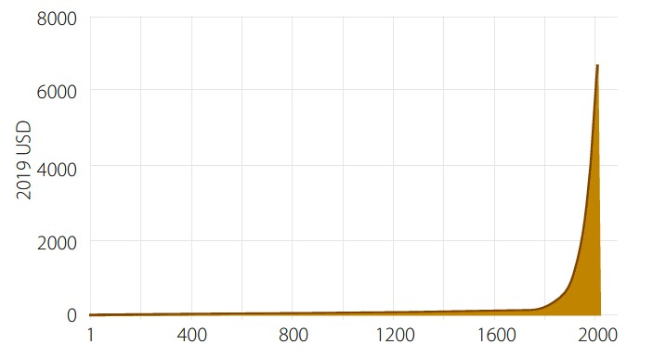
In the mid-1800s, CO₂ levels were at a very low level, about 280 ppm. The great news is that CO2 emissions from nature and fossil fuels has resulted in CO₂ levels rising from this low level to about 415 ppm today.
As a result, crop yields have increased by more than 15% over the past century. Better crop varieties, better use of fertilizer, better water management, etc., have all contributed. But the fact remains that a substantial part of the increase is due to the increase in CO₂ from about 300 ppm in 1850 to about 415 ppm from fossil fuels.
Mathematically, the growth rate of plants is approximately proportional to the square root of the CO₂ concentration. Thus, the increase in CO₂ concentration from about 280 ppm (300 ppm rounded) to 415 ppm over the past century increased growth rates by a factor of about √(4/3) = 1.15, or 15%.
As to temperature, CO₂ is a greenhouse gas and adding CO₂ to the atmosphere by burning coal, oil, and natural gas as a matter of radiation physics can only modestly increase the surface temperature of the earth. Specifically, physics proves that doubling the CO₂ concentration from our current 415 ppm to 830 ppm will directly cause about 1⁰ C in warming.
In summary, the social benefits for people and life all over the world are enormous:
- since CO₂ is a plant fertilizer, agricultural and forestry yields have risen substantially over the last hundred years.
- economies have grown substantially, so that many people have prospered, and poverty has been reduced.
- electricity has become more affordable and available to many more people worldwide.
- and there has been a small but beneficial warming of the planet, about 2° Fahrenheit. This warming has been caused by a combination of natural causes and CO₂ increasing from its low level in 1850 and other greenhouse gases.
See also Goklany, Carbon Dioxide: The Good News (2015) & Happer, “The Truth About Greenhouse Gases,” CO2 Coalition (June 2011).

VII. CONCLUSION
Accordingly, we think it is an important opportunity to do two things.
1st, explain why, with all due respect, science demonstrates that the 4th National Climate Assessment is merely government opinion, and therefore of no scientific value.
2nd, we have the following recommendations on the three scientific areas that the USGCRP is focusing on.
Explain What Is, and Is Not, Science. There is a breakthrough opportunity to inform the public and society on what is, and is not, science. Most people did not have the opportunity to specifically learn what is, and is not, science and scientific method.
Fortunately, the “key to science” and scientific method, in the words of Nobel Prize physicist Richard Feynman, is simple: does the theory work, does it accurately predict what is observed? If the theory doesn’t make accurate prediction of what is observed, the theory is rejected.
The public should not be confused by what does not determine reliable science:
consensus, peer review, government opinion, and manipulated data to make a theory work.
It would be a breakthrough public service if the Decadal Strategic Plan took major steps to inform the public on what is, and is not, science and that scientific method is simply testing a theory’s predictions with observations to see if it works.
Address the Many Ignored Large-Scale Scientific Questions. There are many large-scale scientific questions related to global change and major knowledge gaps and obstacles to implementing scientific knowledge that have been ignored and result from a confusion of what is, and is not, science.
- The International Panel on Climate Change (“IPCC”) and other models used to predict temperatures and scenarios fail the key test of science: they do not work with observations. They therefore must be rejected and not relied on as science in any USGCRP Strategic Plan or NCA.
- The IPCC is government controlled. Therefore it only issues government opinions that have no scientific value. Therefore none of the IPCC findings can be used or relied on as science in any USGCRP Strategic Plan or NCA.
- With all due respect, the Fourth National Climate Assessment’s heavy reliance on IPCC findings means it provides merely government opinion and not reliable science.
- Contrary to scientific method, the enormous benefits of fossil fuels and CO2, and the disastrous consequences of reducing fossil fuels and CO2 to “net zero” are never considered. Scientifically any evidence contrary to any theory must be included and analyzed.
- Other important scientific questions and obstacles to implementing scientific knowledge are set forth in our (Professors Happer and Lindzen) comment on the proposed SEC disclosure rule, https://co2coalition.org/publications/16417/
- Robust additional evidence supporting these recommendations can be found in Gregory Wrightstone, Inconvenient Facts (2017) and the CO2 Coalition website, Home - CO2 Coalition

John Christy, House Comm. Science, Space and Technology (March 29, 2017), link ChristyJR_Written_170329 (house.gov), pp. 3, 5
The one model that closely predicted the temperatures actually observed is a Russian model and is the only model that should be used in science. However, the IPCC did not use it but used the models that it should have rejected.
Donna Framboise. “US Scientific Integrity Rules Repudiate the UN Climate Process (January29, 2017) link US Scientific Integrity Rules Repudiate the UN Climate Process | Big Picture News, Informed Analysis.
Intergovernmental Panel on Climate Change, Principles Governing IPCC Work, the Procedures for the Preparation, Review, Acceptance, Adoption, Approval and Publication of IPCC Reports, Appendix A Sections 4.4-4.6, https://archive.ipcc.ch/news_and_events/docs/factsheets/FS_ipcc_approve.pdf; http://www.ipcc.ch/pdf/ipcc-principles/ipcc-principles-appendix-a-final.pdf (Emphasis added).
EPA, "Endangerment and Cause or Contribute Findings for Greenhouse Gases under Section 202(a) of the Clean Air Act," 74 Fed. Reg. 66496 (Dec. 15, 2009) (“Endangerment Findings”), p. 66511 (footnote omitted).
CO2 Coalition, CO2_3.jpg (1280×720) (co2coalition.org)
Rupert Darwall, Climate Noose: Business, Net Zero and the IPCC’s Anticapitalism Global Warming Policy Foundation, p. 21.

